Active Roles Web Interface

Contents
Document Version Control 1
Approved process for raising 2
Consultation & Approval 2
Change Management 2
How to 3
Testing 3
Communications 3
Downstream Systems & Processes 3
Affected Reports 3
Additional Background Information 3

Document Version Control
Change History/Review Details
Date | Version | Review by | Summary of Change
11-May-2021 | 1.0 | Athena Artuso | Initial draft.

Approved process for raising
Does the change need to be raised through a particular route or by a particular person/team? Are there any actions which need to be taken or considered prior to processing in the HRIS Support Centre?
The Active Roles Web Interface is used by HR Systems to manage access to the HR Reporting environments. Individuals are added to Active Directory (“AD”) groups, and the groups are granted read-only access to folders and sub-folders within the HR Reporting environments. Which AD groups are granted access to which folders/sub-folders is determined by consultation, usually within the Functional Analysis or HR Analytics teams, but often with input from the HR Systems business change advisors.
Note: all users must login to the HR Reporting environments via CONNECT. Users with CONNECT managed desktops will be logged in automatically, but those without CONNECT managed desktops must be set up with a “Global” CONNECT account. The Functional Analysis team are responsible for the creation of these accounts for users of HR Reporting.
Only a small number of people within HR Systems have access to the Active Roles Web Interface to view and manage the AD groups; the site itself is managed by the Microsoft Platform Services Team (“MPST”). MPST are the owners of the Active Roles Web Interface and they can grant or remove access to the site upon request.
There are two different types of AD groups: normal groups, and “super-groups” which are for use solely by report writers and support teams. You can tell which is which by looking at the group name prefix.
- HRIS-RR-… : this is a normal AD group which can be maintained by the Functional Analysis team. Requests for changes to existing AD groups must be raised on OSM as Minor Changes and implemented by the Functional Analysis team.
- HRIS-RS-…: this is a “super-group”. Members of reporting super-groups have total access to the HR Reporting environments, and members of “Report Writers” super-groups are able to publish content to the HR Reporting environments. Super-groups can only be maintained by Microsoft Platform Services, and all changes related to super-group membership must be approved in writing by Simon Burford, Athena Artuso, or Mandy Zaccheo.
Requests for creation of new normal AD groups must be raised on OSM as Minor Changes and a task must be assigned to MPST with details of the new group. These must include:
- Group name – this must be in the format “HRIS-RR-[short descriptive group name]” .
  - Example: HRIS-RR-FINANCE_BFT
- Description – a description of the group you wish to create.
  - Example: Finance Budgeting & Forecasting Team
MPST will create the group profile, and the Functional Analysis team can then add individual staff members.
Requests for creation of new super-groups must be raised on OSM as Minor Changes, but only after written approval has been granted by Simon Burford, Athena Artuso, or Mandy Zaccheo. A task must be assigned to MPST with details of the new group. These must include:
- Group name – this must be in the format “HRIS-RS-[short descriptive group name]”
  - Example: HRIS-RS-PowerBI Report Writers – Project Teams
- Members – a list of the individuals (fullname + SSO) whom you wish to be added to the new super-group.
  - Example: Athena Artuso (admn4134)
If someone is requesting access to the Active Roles Web Interface itself to view or manage the information there, an OSM Minor Change request must be raised and a task sent to the Microsoft Platform Services Team (“MPST”). Only MPST are able to manage access to the Active Roles Web Interface.
Note: Only the Functional Analysis team should have read-write access to the Active Roles Web Interface; this is to ensure the careful management of access to the HR Reporting environments. Members of other teams such as the HRIS Support Centre may require read-only access to the Active Roles Web Interface to help them investigate customer queries, but they should not be given read-write access.

Consultation & Approval
Who is the owner of this information? Who needs to be consulted about this change before you begin work on it? Does anyone need to approve this change before it is implemented?
Creation of new “super-groups” and changes to existing super-groups is reliant on written approval from Simon Burford/Athena Artuso, or Mandy Zaccheo, as outlined below:
Group | Approval needed from…
HRIS-RS-PowerBI Report Writers - Production | Simon Burford or Athena Artuso
HRIS-RS-PowerBI Reporting Administrators - Production | Simon Burford or Athena Artuso
HRIS-RS-PowerBI Report Writers - Project Teams | Simon Burford or Athena Artuso
HRIS-RS-PowerBI Reporting Support - Production | Mandy Zaccheo
HRIS-RS-PowerBI Report Writers - Non Production | Simon Burford or Athena Artuso
HRIS-RS-PowerBI Reporting Administrators - Non Production | Simon Burford or Athena Artuso
HRIS-RS-PowerBI Reporting Support - Non Production | Simon Burford or Athena Artuso
Creation of new normal AD groups and management of existing normal AD groups should be done via consultation with the Senior Business Change Advisor (Tonya Iasisen-Kandola), who will reach out to the end users in question to determine who requires access to which group of reports. Once changes have been raised, approval may be sought in the usual way from the Head of HR Systems (Jenny Lister).
Creation of a Global CONNECT account may not require a change record in OSM – Michael O’Sullivan to confirm process.
A change to add or remove a staff member’s access to the Active Roles Web Interface itself will need to be implemented by MPST, as detailed above; however approval for the change must be granted by:
- Mandy Zaccheo for read-only access requests
- Simon Burford for read-write access requests

Change Management
What type of change is this? When should approval be sought and from whom (internal to team or change manager)? Who would normally be responsible for implementing?
Changes to AD groups within the Active Roles Web Interface, and changes to user access to the Active Roles Web Interface itself, are both “Minor Changes” in OSM.
- Service Line – Business Systems and Administration Support
- Service – HRIS
- Category – HR Reporting
- Justification – Configuration (in the sense that this is configuring access to either HR Reporting or the Active Roles Web Interface)

How to
Technically how to process the change in the system
A very basic guide to managing existing AD groups is provided here; a separate how-to can be created if required. A guide to creating Global CONNECT accounts is also needed.
Adding a new member to an AD group
Navigate to: https://activeroles.it.ox.ac.uk/Service/default.aspx
On the landing screen, select Search.

Search for the name of the AD group you wish to modify. Select the group and in the right-hand menu bar, select “Members”:
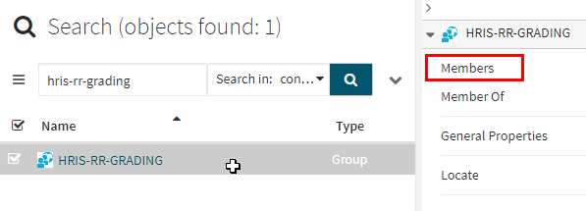
The screen will refresh and a list of the group’s members will be displayed. To add a new member (or members), click the “Add…” button:
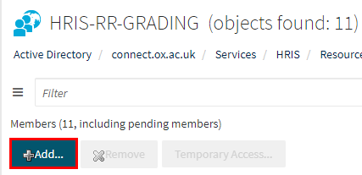
Search for the name you wish to add and select the relevant record(s); then click OK at the bottom of the screen to commit your changes:
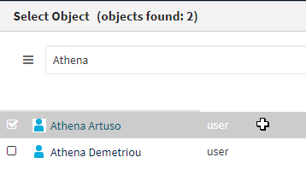

Removing a member from an AD group
Navigate to: https://activeroles.it.ox.ac.uk/Service/default.aspx
Search for and select the AD group in question and open the “Members” screen, as detailed above. Select the member(s) you wish to remove and click the “Remove…” button.
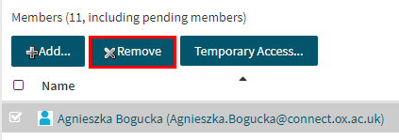
A warning message will pop up. Click “Yes” to commit your changes.
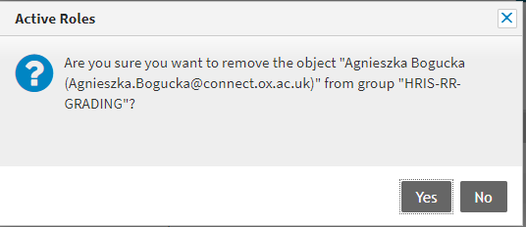

Testing
Who would normally be responsible for testing? Are there standard items to test?
The Active Roles Web Interface is a live system; there is no method for testing the changes made within it before they are implemented. However, it is best practice to ask individuals who have been added to AD groups to confirm that they can access the relevant areas of the HR Reporting environments (what is relevant will depend on which AD group they belong to; e.g. adding someone to the Payroll team group should grant them access to the Payroll folder and all subfolders, as well as many Pensions reports).
Individuals who have been set up with Global CONNECT accounts must check and confirm whether they are able to log into the HR Reporting environment via their new accounts.
If someone has been granted access to the Active Roles Web Interface, they will need to check and confirm that they are able to access the site and read its contents. Users with read-write access should check that they have the ability to add and remove individuals from existing AD groups.

Communications
Who needs to be informed (but not consulted) about this change? Detail when they should be informed (before or after the change).
Whoever has requested addition to or removal from an existing AD group (whether for themselves or, as is more likely, on behalf of another user) should be informed once the change has been implemented. Similarly, whoever has requested creation of a new AD group should be informed once the group has been created and members added.
Finally, whoever has requested access (read-only or read-write) to the Active Roles Web Interface should be informed once MPST have granted that access.

Downstream Systems & Processes
Details of any processes which are affected or need to be carried out following, or as part of, the change. Please detail any triggers, actions required and when the actions should be carried out.
Both the creation of Global CONNECT accounts and changes to existing AD groups within the Active Roles Web Interface directly impact user access to the HR Reporting environments, and as such must be handled very carefully to prevent users from accessing report data unnecessarily.
Changes to user access to the Active Roles Web Interface have a secondary impact on management of existing AD groups. Only members of the Functional Analysis team should have read-write access to the Active Roles Web Interface for creation of Global CONNECT accounts and management of AD groups, to ensure that reporting access is tightly controlled.

Additional Background Information
Any other relevant information, links to supporting documentation etc.

